Reality Counseling for Drug Prisoners in Adjustment Period in Prison

Fadila
IAIN Curup
unifadila@gmail.com

Corresponding email: unifadila@gmail.com

Abstract

This study aims to help new inmates, especially inmates who are involved with drug cases, to be able to adapt and be responsible in a new environment, in the Class II A Curup Prison, Rejang Lebong Regency. This study uses a Mix Method approach. The research data used are primary data and secondary data. Primary data was obtained from a questionnaire, while secondary data was obtained from literature studies, internet website searches and also obtained from documentation at the Class II A Curup prison institution. The data analysis technique is by taking measurements, selecting samples using purposive sampling technique, providing reality counseling services, conducting self-evaluation of new inmates after being given counseling, then making conclusions based on the verification of the data obtained. The results of this study showed that out of 10 inmates, 7 people had a low level of adjustment and 3 people had a moderate level of adjustment. The implementation of this reality counseling makes the inmates specifically for drugs smarter in adjusting to the environment they face so that their thinking becomes more rational and their anxiety can be overcome. Based on the results of the analysis, it can be seen that the probability number of Asmyp. Sig.(2-tailed) adjustment of inmates specifically for drugs in prison Class II A is 0.005 or probability below alpha 0.05 (0.005 < 0.05), from these results it can be concluded that the level of adjustment of inmates specifically for drugs in Class II A prisons improved significantly after being given Reality Counseling.
Keywords: Reality Counseling, Drug Prisoners, Adjustment

INTRODUCTION
Background In Law Number 12 of 1995 concerning Corrections Article 1 paragraph 1 explains that correctional facilities are activities to carry out guidance for inmates based on systems, institutions, and coaching methods which are the final part of the criminal justice system in the criminal justice system. Paragraph 2 states that the correctional system is an arrangement regarding the direction and boundaries as well as the guidance of inmates based on Pancasila which is carried out in an integrated manner between the coaches, those who are fostered, and the community to improve the quality of prisoners in prison so that they are aware of mistakes, improve themselves, and do not repeat criminal acts so that can be re-accepted by the community, can play an active role in development, and can live normally as a good and responsible citizen. while paragraph 3 explains that correctional institutions, hereinafter referred to as prisons, are places to carry out coaching for prisoners and correctional students. Paragraph 5 explains that correctional inmates are prisoners, correctional students and correctional clients (Republic of Indonesia, 1995).
Imprisonment in the correctional system is carried out while still upholding the dignity and worth of a human being. The treatment is intended to keep inmates positioned not only as objects, but also subjects in the coaching process with the ultimate goal of returning the inmates to the midst of society as good and useful people (Haryono, 2017). When a prisoner is admitted to a prison as a new inmate, of course, he still feels foreign in facing the new environment. Feelings of fear, feelings of anxiety will surely haunt and disturb the psyche of the new inmates, including the Class II A Curup Prison in Rejang Lebong Regency, because inside the prison, other inmates from all walks of life will join with different types of criminal cases. In prison inmates face conditions that are completely limited and binding prison regulations that cause a sense of dissatisfaction which results in mental tension which eventually leads to both physical and spiritual pain (Prawiratama, 2020). To overcome this problem, it is necessary to provide guidance and counseling for new inmates. Guidance or guidance efforts, which are the core of the activities of the correctional system, are a means of treating inmates in a new way to support a new pattern of efforts to implement imprisonment in order to achieve the success of the role of the state in removing inmates to return to being members of the community (Haryono, 2017). Reality therapy is one of the counseling that can be given to new inmates in prisons to overcome the problems of fear and anxiety as well as bullying done by other inmates.
Reality therapy was first developed by William Glasser in the 1950s and 1960s. Glasser developed reality therapy out of his belief that conventional psychiatry is largely based on erroneous assumptions. reality therapy, which outlines principles and procedures designed to assist people in achieving a “success identity”, can be applied to psychotherapy, counseling, teaching, institutional management and community development (Corey, 2005). The goal of reality therapy is to help clients reconnect with those around them, both old and new. The main goal of therapy is to help clients improve significant relationships in their lives (Corey, 2013). Reality therapy is a system focused on present behavior. This reality therapy is active, directive, psychoeducational, and didactic. The relationship between the counselor and the client is the counselor assisting the client in making plans to change the client's behavior for the better. Structured/skilled questions and various behavioral methods are used to encourage clients to evaluate what they are doing. If clients decide that their current behavior is ineffective, they develop a specific plan for change and make a commitment to follow it.

Problem Formulation
Based on the background of the problem, questions that become the focus of this research can be made, including:
- How to adjust to new inmates, especially drug cases in Class II A Curup Prison before being given counseling services.
- How reality counseling can overcome the anxiety faced by new inmates, especially drug inmates in Class II A Curup Prisons.
- How is the adjustment of the new inmates after the implementation of reality counseling.

Purpose
To help new inmates, especially inmates who are involved in drug cases, to be able to adjust and be responsible in the new environment, namely the Class II A Curup Prison, Rejang Lebong Regency.

RESEARCH METHODOLOGY
Approach
This study uses a Mix Method approach which is data collection and integration of quantitative and qualitative data in one study so that it can produce a more comprehensive understanding of the problem being studied (Leavy, 2017). While the research model used in this mix method is a sequential explanatory model (Creswell, 2018).

Data Collection Method
The research data used are primary data and secondary data. Primary data were obtained from questionnaires given and through counseling given to new inmates, especially inmates with drug cases in Class II A Curup Prison. While secondary data were obtained from literature and literature studies, internet website searches and also obtained from documentation at the Class II A Curup prison institution.

Data Analysis Techniques
Measuring the level of adjustment of the new inmates through a given questionnaire. Selecting a sample using purposive sampling technique based on the results of a questionnaire that has a low self-adjustment score. The new inmates who are the selected samples will be provided with reality counseling services. Conduct a self-evaluation of the new inmates after being given counseling, then make conclusions based on the verification of the data obtained.

FINDINGS AND DISCUSSION
The Basic Concept of Reality Counseling
Reality Counseling is a system that focuses on present behavior. The counselor functions as a teacher and model and confronts the counselee in ways that can help face reality and meet basic needs without harming themselves or others. The essence of Reality Counseling is the acceptance of personal responsibility, which is equated with mental health. Reality counseling which outlines principles and procedures designed to assist individuals in achieving a “success identity” can be applied to psychocounseling, counselling, teaching, group work, marriage counselling, institutional management and community development. Reality counseling is a form of behavior modification because, in its institutional applications, it is a non-strict type of operant conditioning (Corey, 2010). Most of the problems experienced by counselees are caused by their inability to relate, get along with other individuals, or to have a good relationship with at least one of the important individuals in their lives. Few counselees have a clear understanding that their problem is the behavior they choose. What they don't know is that they are suffering or they are unhappy because they have been sent to counseling by a powerful individual who is displeased with their behavior, particularly by the principal, school staff, spouse or parent. Reality counseling understands that counselees choose their behavior as a way to deal with frustration caused by poor relationships. Counseling basically teaches clients to make more effective choices because they connect with the individuals they need in their lives. Because choice theory explains how to choose to behave in ways that can improve relationships, teaching choice theory to counselees is part of Reality Counseling (Corey, 2009). In reality counseling, individuals must be brave to face reality and be willing not to repeat the past. The important thing that individuals have to deal with is trying to replace and make intentions for the future. Counselors in reality counseling are tasked with helping individuals make specific plans for their behavior and make a commitment to implement the plans that have been made. In this case, self-identity is an important human social need that must be developed through interaction with others, as well as with oneself. Changes in identity are usually followed by changes in behavior where the individual must be willing to change what he does and adopt a new behavior. Reality counseling is focused on helping individuals to understand and accept their own limitations and abilities. Basically every individual is driven to fulfill his needs and desires, where needs are universal in all individuals, while desires are unique to each individual. When a person can fulfill what he wants, that need is satisfied. However, if what is obtained is not in accordance with the wishes, then people will be frustrated, and in the end will continue to bring up new behaviors until their desires are satisfied. That is, when there is a difference between what is desired and what is obtained, the individual continues to produce specific behaviors. So, the behavior that appears is purposeful, which is formed to overcome the barriers between what is desired and what is obtained, or arises because it is chosen by the individual. Human behavior is the total behavior of total behavior, consisting of doing, thinking, feeling and psychology (Gantina Komalasari, et al, 2011). Based on the description above, it can be concluded that Reality Counseling can be said to be a form of practical, relatively simple help relationship and a form of direct assistance to the counselee, which can be carried out by teachers or counselors in schools in order to develop and nurture the personality of the counselee's mental health successfully, by give responsibility to the counselee concerned.

The basic concept of adjustment
Fatimah (2008) states, "Self-adjustment is a natural and dynamic process that aims to change individual behavior so that there is a relationship that is more in line with environmental conditions". This illustrates that self-adjustment is a process that is always developing in changing the behavior of an individual. A person is said to have a good adjustment ability (well adjusted person) if he is able to make mature, efficient, satisfying and healthy responses. Said to be efficient means being able to respond by expending energy and time as efficiently as possible. It is said to be healthy, meaning that the responses are carried out in accordance with the nature of individuals, institutions, or groups between individuals, and it is even said to be satisfactory that this healthy trait is the most prominent characteristic description to see and determine that an adjustment is said to be good. Ideally a person has been able to adapt himself either to other people or to the environment in which they live, but in reality, individuals are not always successful in adapting. This is due to certain obstacles or obstacles that cause individuals to be unable to make adjustments optimally. The obstacles can come from within him (limitations) or maybe from outside him. Schneiders (1964) states, "Personality it self functions as a primary determinant of adjustment". Personality is an important key in self-adjustment. This personality is influenced by five factors, namely: (1) physical condition (physical condition), (2) development and maturation (development and growth), (3) psychological determinants (psychological influence), (4) environmental condition (environmental conditions), (5) cultural determinants including religion (culture and religion). Fatimah (2008: 195) explains that self-adjustment is divided into two forms, namely positive self-adjustment and inappropriate adjustment (misadjustment). Individuals who are classified as being able to make positive adjustments are characterized by the following: (1) not showing excessive emotional tension, (2) not showing any self-defense mechanisms, (3) not showing personal frustration, (4) having rational considerations in self-direction, (5) learning from experience, and (6) realistic and objective. Meanwhile, misadjustment is characterized by defensive reactions (self-defense mechanisms), attack reactions, and escape reactions.

Research Results
Pretest Results
In accordance with the purpose of the pretest, which is to describe the initial condition of the inmates' level of adjustment before being given reality counseling. The following is the condition of the pretest adjustment to narcotics inmates in class II A Curup prisons.
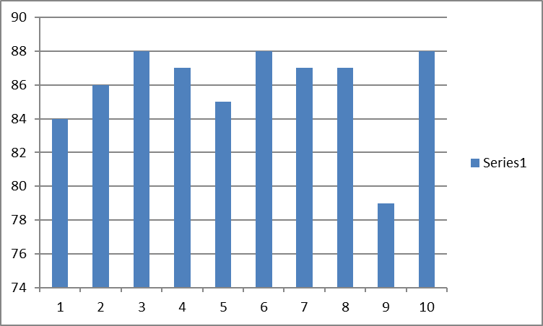

The data obtained from the pretest results showed that out of 10 inmates, 7 people had a low level of adjustment and 3 people had a moderate level of adjustment. The results of the division of groups based on the data obtained, resulted in an average pretest score of adjustment of the inmates in the experimental group of 85.9 and in the low category. The following is a description of the conditions of adjustment of the inmates in the experimental group and the control group. The pretest data can be seen in Table below.

Table 1. Pre-test Data
Interval | Kategori | Frekuensi | N | %
142 – 170 | Sangat Tinggi | 0 | 0 | 0
115 – 141 | Tinggi | 0 | 0 | 0
88 – 114 | Sedang | 3 | 0 | 30
61 – 87 | Rendah | 7 | 7 | 70
34 – 60 | Sangat Rendah | 0 | 0 | 0
Jumlah |  | 10 | 10 | 100

Based on table 8, it is known that out of 10 inmates, 70% (7 people) have low self-adjustment and 30% (3 people) are in the moderate category.

Posttest Results
After being given reality counseling for 10 (ten) meetings to the inmates specifically for drugs for approximately two months, the researchers then measured the level of adjustment of the inmates specifically for drugs. The measurement results can be seen in the following image
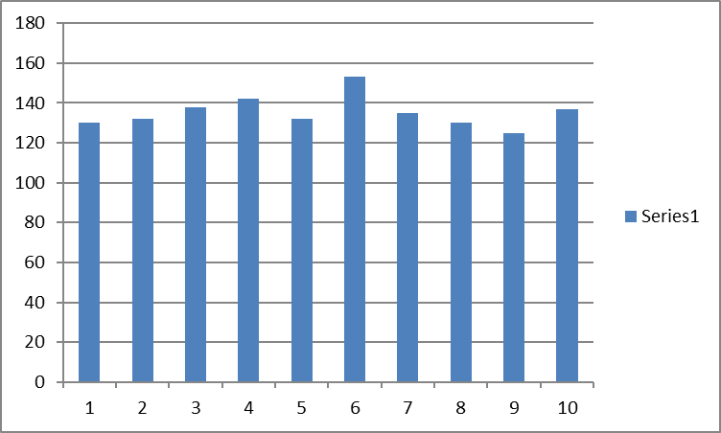

Based on the results of the posttest, it can be seen the difference in values between the results of the pretest and posttest. The results of the post test showed that out of 10 inmates, 2 inmates were in the very high category and 8 inmates were in the high category. The following is a description of the condition of the adjustment level of inmates specifically for drugs in the Class A Curup prison. The posttest result data can be seen in the frequency distribution table below.

Table 2. Post-test Result
Interval | Kategori | Frekuensi | N | %
142 – 170 | Sangat Tinggi | 2 | 2 | 20
115 – 141 | Tinggi | 8 | 8 | 80
88 – 114 | Sedang | 0 | 0 | 0
61 – 87 | Rendah | 0 | 0 | 0
34 – 60 | Sangat Rendah | 0 | 0 | 0
Jumlah |  | 10 | 10 | 100

Based on the table above, it is known that out of 10 inmates who have a very high level of adjustment, 20% (2 inmates) and students who have a high level of adjustment are 80% (8 inmates).

Data from Pretest and Posttest Results
The research data obtained before and after being given reality counseling services can be seen in the following figure.
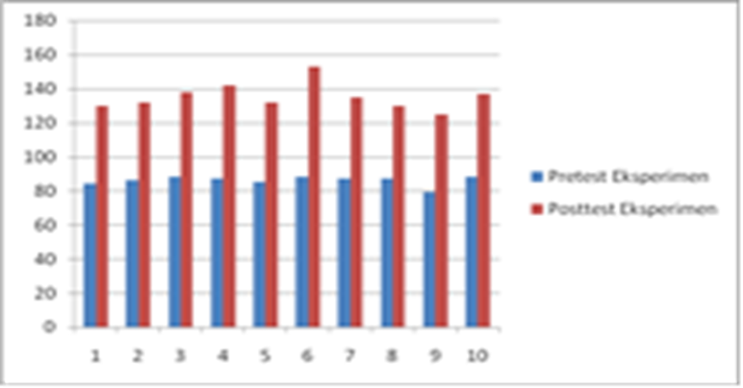
fig: Histogram of Pretest and Posttest Results of Self-Adjustment of Special Inmates for Drugs in Class II A Curup Prison

Based on the picture above, it can be seen that the adjustment of the inmates specifically for drugs in the Curup Class II prison increased after being given treatment with reality counseling services. Based on the results of the analysis, it can be seen that the probability number of Asmyp. Sig.(2-tailed) adjustment of inmates specifically for drugs in prison Class II A is 0.005 or probability below alpha 0.05 (0.005 < 0.05), from these results it can be concluded that there are differences in adjustment of special inmates Drugs in class II A prisons are poor before and after being given reality counseling. Based on the data obtained, it can be interpreted that the level of adjustment of inmates specifically for drugs in Class II A prisons is quite increasing after being given Reality Counseling.
Adjustment is the first step for a human being to get along with the surrounding environment. someone who has a good adjustment then he will easily get along and adapt to the new environment faced. Therefore, it is necessary to make efforts to assist new inmates in adjusting to the prison environment, one of the efforts is to provide services using reality counseling which has been proven to be effective in helping to improve the adjustment of inmates, especially drugs in class II A prisons. Schneiders (in Ghufron & Risnawita, 2010: 50) argues that people are said to be less able to adjust or have low self-adjustment, if the sadness, disappointment or hopelessness develops and affects their physiological and psychological functions. Individuals become unable to use thoughts and attitudes properly so that they are unable to cope with the pressures that arise in a good way. Individual failure in self-adjustment can cause, among others: excessive emotional tension, faulty self-defense mechanisms, personal frustration, having irrational considerations in self-direction, failing to learn from experience, being unrealistic and not objective. The results obtained from the implementation of reality counseling make the inmates specifically for drugs smarter in adjusting to the environment they face so that their thinking becomes more rational and their anxiety can be overcome. Because adjustment to the new environment occurs not only temporarily but when they face a new situation, a new adjustment is needed as well.

CLOSING
Based on the results of the study, it can be concluded that the pretest results show that of the 10 inmates, 7 people have a low level of adjustment and 3 people have a moderate level of adjustment. The implementation of this reality counseling makes the inmates specifically for drugs smarter in adjusting to the environment they face so that their thinking becomes more rational and their anxiety can be overcome. Because adjustment to the new environment occurs not only temporarily but when they face a new situation, a new adjustment is needed as well. Based on the results of the analysis, it can be seen that the probability number of Asmyp. Sig.(2-tailed) adjustment of inmates specifically for drugs in prison Class II A is 0.005 or probability below alpha 0.05 (0.005 < 0.05), from these results it can be concluded that there are differences in adjustment of special inmates Drugs in class II A prisons are poor before and after being given reality counseling. Based on the data obtained, it can be interpreted that the level of adjustment of the inmates specifically for drugs in Class II A prisons is quite increasing after being given Reality Counseling.

References

Corey, G. (2005). Teori dan Praktek Konseling dan Psikoterapi (Kedua). PT. Refika Aditama.
Corey, G. (2013). Case Approach to Counseling and Psycotherapy (Eighth). Brooks/Cole CENGAGE Learning.
Creswell, J. W. (2018). Research Design : Quantitative, Qualitative, Mixed Methods Approaches (Fifth Edit). SAGE Publications Ltd. https://lccn.loc.gov/2017044644%0D
Haryono. (2017). Kebijakan Perlakuan Khusus Terhadap Narapidana Risiko Tinggi di Lembaga Pemasyarakatan (Studi Kasus di Lembaga Pemasyarakatan Kls III Gn . Sindur ). Jikh, 11(3), 231–247.
Leavy, P. (2017). Research Design : Quantitative, Qualitative, Mixed Methods, Arts-Based, and Community-Based Participatory Research Approaches (nineth Edi). The Guilford Press. www.guilford.com
Prawiratama, A. (2020). Masa Pengenalan Lingkungan Dan Penyesuaian Diri Tahanan Baru Dalam Rumah Tahanan Negara. JUSTITIA : Jurnal Ilmu Hukum Dan Humaniora, 7(2), 257–269. http://jurnal.um-tapsel.ac
Republik Indonesia. (1995). Undang-Undang Nomor 12 Tahun 1995 tentang Pemasyarakatan. Journal of Geotechnical and Geoenvironmental Engineering ASCE, 120(11), 259. www.bphn.go.id
Fatimah, E. 2008. Psikologi Perkembangan (Perkembangan Peserta Didik). Bandung: Pustaka Setia.

Schneiders, A. A. 1964. Personal Adjustment and Mental Health. New York: Library of Congress Catalog.

